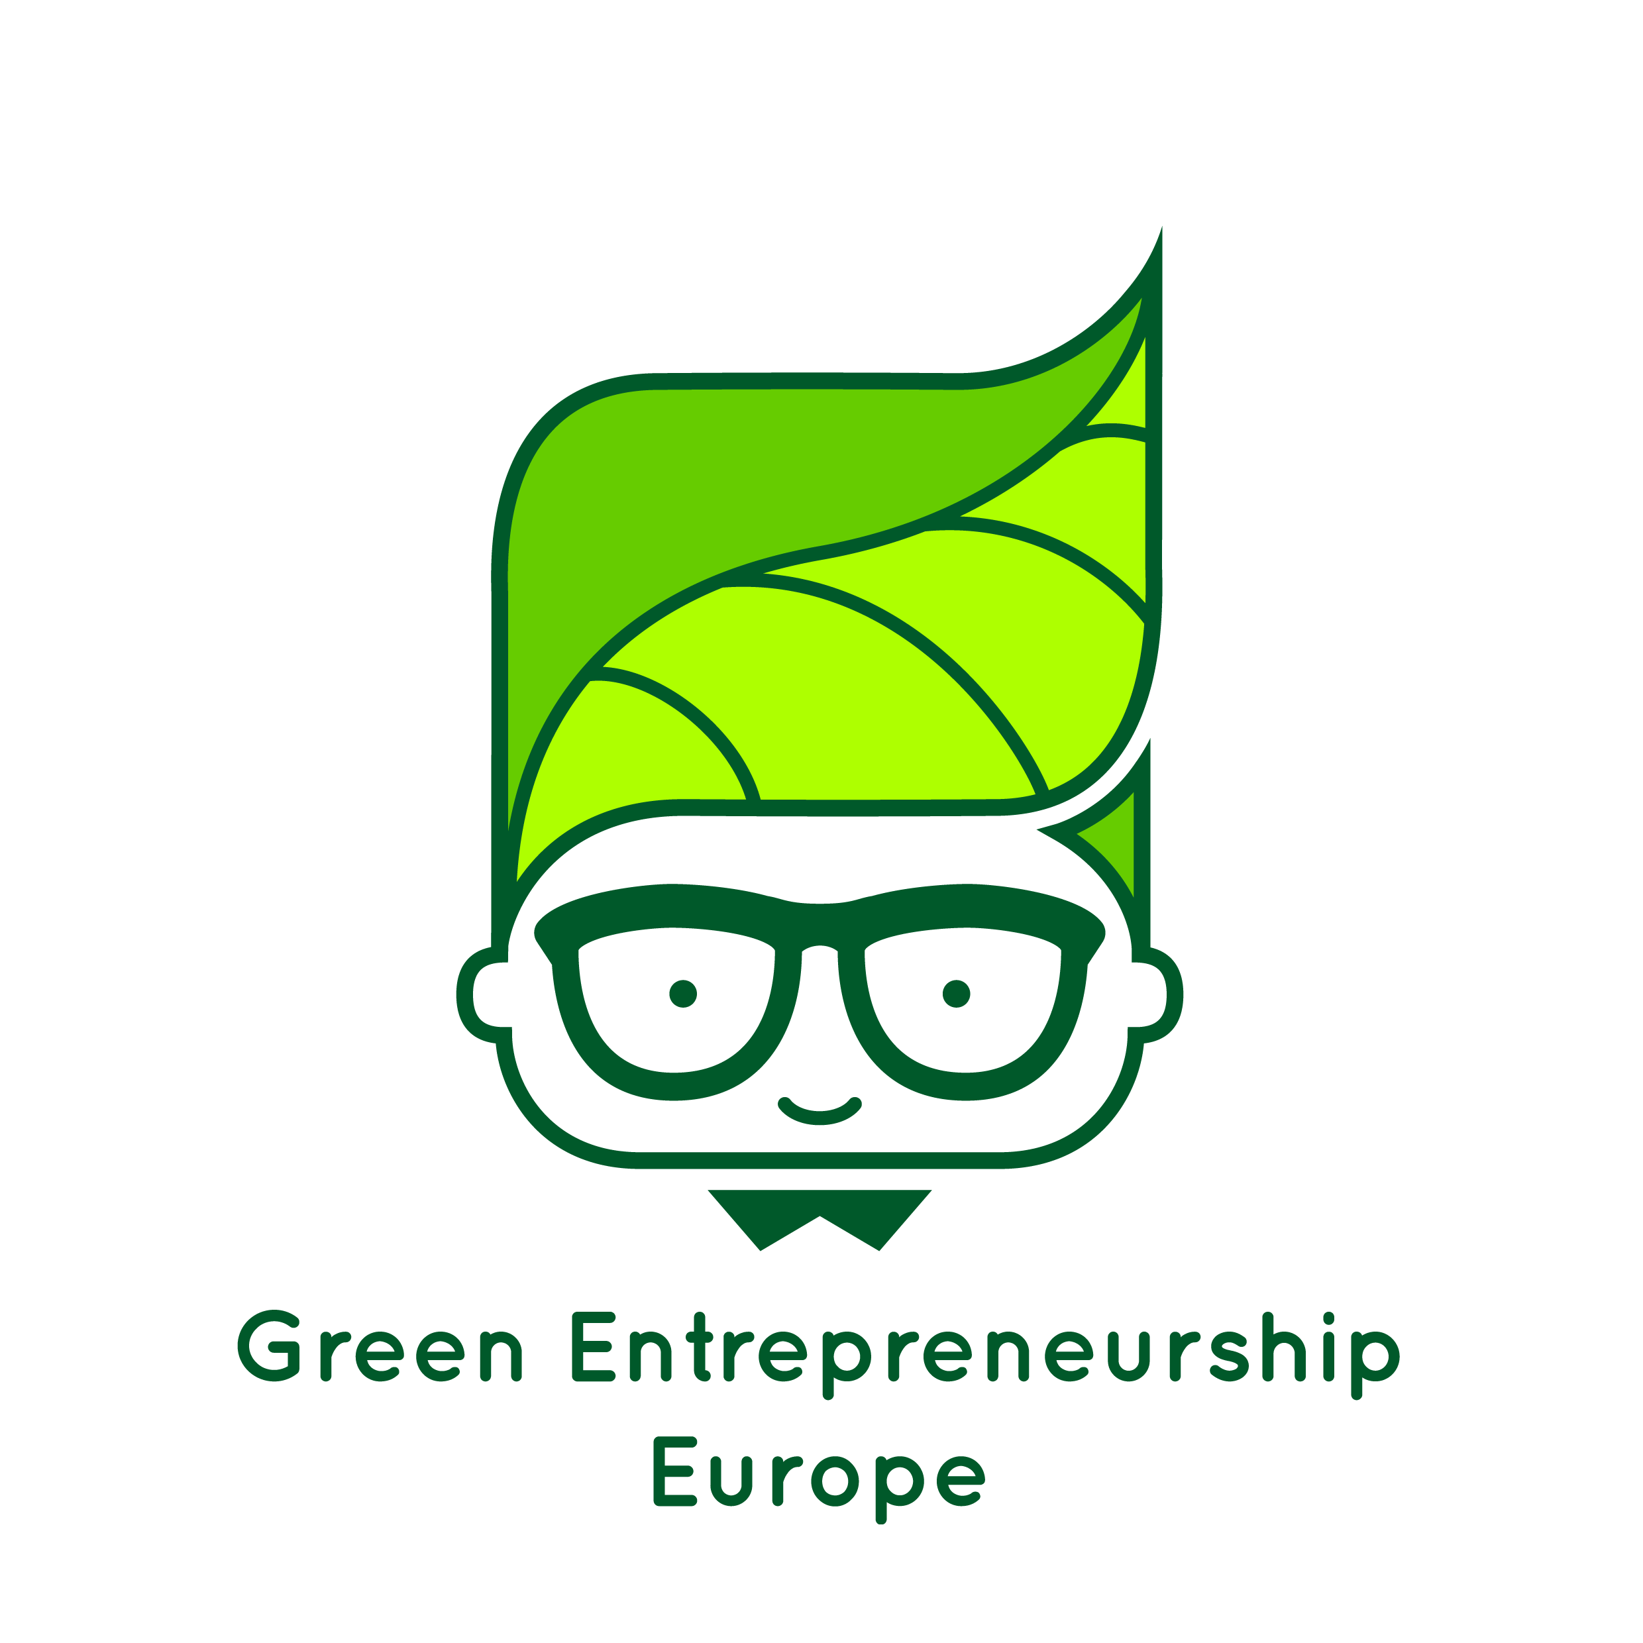
Business planning guidelines
“The European Commission support for the production of this publication does not constitute an endorsement of the contents which reflects the views only of the authors, and the Commission cannot be held responsible for any use which may be made of the information contained therein."

The business planning part of the GEE project will probably the most unfamiliar part for your students. Feedback from pilot schools suggested that this was the part that students found the most difficult. With this in mind, this document has been produced to help you guide your students through the business planning stage.

Below is an overview of how students build up their knowledge and exposure to businesses and business planning through out the GEE modules.

Module | Business & business planning links
1: what might change? | - The concept of entrepreneurship is introduced and what kind of skills entrepreneurs need to establish successful businesses.  - Optional videos can be shown to students giving snapshots of real young entrepreneurs and the kind of businesses they’ve established.
2: lessons from nature | There are 5 options for this, so the content varies depending on the module chosen. Each module includes:  - Videos to highlight sustainable business relevant the topic.  - Time for students to reflect and think about their ideas (space for this is provided on the double page spread on ‘lessons from nature’ in the student booklet.  - In some modules students start to think about how they make a business idea linked to their lfn topic
3:  changing perspectives | This is where students get introduced to the process of business planning in the following ways:  - e-learning module. This is a program which takes students through all the steps involved in creating a business plan. They learn about what a business plan contains, take a quiz on the topic and learn about some example businesses through short case studies and a video.  - Case studies lesson. Students are given a case study of a green/ circular business. From the information, they create a business plan for the business. eg What is their product, who might their competitors be? Who is their target audience etc. This gives students practice using the framework of a business plan, while ‘knowing’ the answers.  - Coffee House challenge (CHC) See ‘Planning a coffee house challenge’ (website: learning materials- modules)- a chance to learn from business people/ entrepreneurs.
4 entrepreneurial thinking | This is the section where students create their own business idea and write the business plan around this. At this point some groups will have already formed an idea and be happy to start writing their business plan.  - Business plan: this is downloadable at the end of the e-learning module and is also available on the GEE website, under resources. There is a simplified version if you think your students might struggle.  - There are ideas in the learning pack of how to help groups who are struggling to come up with a good idea. See also below
5 the way forward | - This section is about reflecting on what could be improved, how their business would evolve, which are important skills to develop.

Top tips to support your students in developing their green business ideas

Are you/ your students struggling with confidence?

- Show students some the optional videos in module 1. These all feature children who have developed an idea and brought it to market; some of them earning significant money from it.
- As you come across examples of green businesses, encourage students to write down ideas that they like/ could adapt. There is space in their booklets on the ‘lessons from nature’ double page spread for this.
- If you have students who are particularly creative, mix them up with students who aren’t.
- Encourage lots of ideas sharing and thought showers thought the process. This gets students used to sharing and contributing
- Encourage the ethos: no idea is a bad idea. Who would have have thought in the ‘70s that a telephone could take photos and play you your favourite music?
- Watch the video of the entrepreneur Pete Dowds presenting to our pilot school. He was very personable and encouraging, and showed that he had a fair few lows and problems before making it in business. See www.geelearnign.eu ‘success stories’ tab then ‘Success story: coffee house challenge’

Students have no idea/ don’t know where to start.

- Encourage students to use the ideas matrix in their booklets. They fill out a blank version of the table below, filling in their own hobbies and passions, ideas for environmental problems and things they think are a necessity. They can then match these up and see if any ideas come out from this.

Hobbies | Passions | Environmental problems | Necessity
Cleaning | Keeping fit | Air pollution | Air
Dancing | Poetry | Landfill | Food
Films | Green issues | Loss of biodiversity | Water

An environmentally-friendly cleaning product? A sustainable car washing service?

- ‘Steal’ ideas. Encourage students to think about a case study they liked and think of a similar idea. Good ones to suggest are:
- Splosh (concentrated sachets of cleaning products sent through the post, where the consumer adds tap-water). They could do this with shampoo/ shower gel/ beauty products.
- Mud Jeans (renting jeans which get returned, shredded and re-used). This could be done with other clothes, or things like jewellery
- Spare fruit (where fruit that doesn’t meet the supermarket standard because it’s too small/ deformed/ wrong colour is turned into dried fruit crisps). There is lots that can be done with food waste, eg creating biogas, making jam/ syrups from rejected fruit, supplying homeless shelters, creating a ‘leftover food’ café, where the cheap menu depends on the food available.
- Base ideas around school. Task students with coming up with ways of making the uniform/ canteen/ stationary/ energy & heating around school more circular.

